

County Housing
Hillsdale Housing Authority
Pagedale Housing Authority
Olivette Housing Authority

SECTION 3 BUSINESS APPLICATION

Completed applications should be submitted to
section3@countyhousing.org
Or delivered to:
8865 Natural Bridge Road
St. Louis, MO 63121

Section 3 Business Application Checklist

Date Business Name

Owner/President Phone ____________________________

- Complete Section 3 Business Application
- Organizational Information
  - Articles of Incorporation
  - Assumed Business Name Certificate
  - Certificate of Good Standing
  - Partnership Agreement
  - Organizational Chart with Job Titles and Duties
  - Evidence of Business License
  - Other Applicable Documentation
- Qualifying Section 3 Criteria (Check applicable qualifying criteria below and include all requested supporting documentation)
  - At least 51 percent of the business is owned and controlled by low- or very low-income persons, or
  - At least 51 percent of the business is owned and controlled by current public housing residents or residents who currently live in Section 8-assisted housing, or
  - Over 75 percent of the labor hours performed for the business over the prior three-month period are performed by Section 3 workers.
- Other Pertinent Information
  - Insurance Certificates
  - Current Financial Statement
  - Statement of Ability to Comply with Public Policy
  - List of all Contracts for the Past 2 Years
  - W-9
CONTACT INFORMATION

Name of Business___________________________________________________________________

Physical Address____________________________________________________________________

City, State, Zip_______________________________________________________________________

Mailing Address, if different___________________________________________________________

City, State, Zip_______________________________________________________________________

Owner’s Name (Please include a copy of State ID or Driver’s License)______________________

Telephone Number, including area code_______________________________________________

Email_______________________________________________________________________________

ORGANIZATIONAL INFORMATION

All questions must be answered, and the data given must be clear and comprehensive. Attach additional pages as needed.

Date the business was established_____________________________________________________

The business is a:
□ Sole Proprietorship □ Partnership □ Joint Venture □ Limited Liability Company (LLC)
□ Corporation (If a corporation, please enclose a copy of corporation papers and corporate seal)

General type of work performed by the business (i.e. general contracting, HVAC, etc):

Is the business minority-owned (MBE)? Yes □ No □ Woman-owned (WBE)? Yes □ No □
(Optional: For statistical purposes only)

The applicant must have the necessary St. Louis County licenses and submit copies to the Housing Authority of St. Louis County.

Is the business licensed in St. Louis County, Missouri? Yes □ No □ (Enclose a copy if Yes)

Is the business Section 3-certified with St. Louis County, the City of St. Louis, or the Housing Authority of St. Louis? Yes □ No □ (Enclose a copy if Yes)

Please check and attach the following Business Entity documents, as applicable:
Copy of Articles of Incorporation Assumed Business Name Certificate
Certificate of Good Standing Partnership Agreement
Organization Chart with Titles Other Documentation

The Applicant must have at least the following insurance coverage for Section 3 contract work:
- Commercial General Liability on an occurrence form for:
    - Bodily injury, and
    - Property damage liability
General Contractor limits of $2,000,000 combined single limit each occurrence covering the Project specifically, and umbrella excess liability of $5,000,000
Subcontractor limits will be $1,000,000 combined single limit occurrence, and $2,000,000 umbrella excess liability
- Worker’s Compensation:
    - Statutory limits required by State Law
    - Employer’s Liability: $100,000
- Comprehensive Automobile Liability
    - Bodily Injury: $1,000,000 Each Person
$1,000,000 Each Occurrence
    - Property Damage: $1,000,000 Each Occurrence

A copy of the above insurance certificates must accompany this application. Coverage shall be maintained for the life of each contract or subcontract. Lapse of coverage may result in termination of the contract and/or termination of approval to participate by the St. Louis County Office of Community Development.

The Applicant must have a satisfactory record of past work. Applicants with limited or no past performance will be accepted on a “probation” basis and will not be awarded more than one contract at a time.

Provide evidence of ability to perform successfully under the terms and conditions of other contracts:
- Current Financial Statement
- Statement of ability to comply with public policy
- List of all contracts for the past two (2) years

QUALIFYING SECTION 3 CRITERIA

The Applicant must satisfy at least one of the following minimum requirements to be qualified as a Section 3 Business Concern. Attach additional pages as needed. The Resident Application must also be completed and submitted if claiming eligibility based on household income. Please check the appropriate box(es):

1. A majority 51% or more ownership of Applicant business shall be held by low- to very low-income residents who reside within the boundaries of St. Louis County, Missouri, part of a Metropolitan Statistical Area (MSA), as recognized by the U.S. Department of Housing and Urban Development. If eligible, owner(s) must submit a copy of a public housing lease, a copy of a receipt of public assistance, a
copy of evidence of participation in a public assistance program, or be income eligible (see Exhibit A).

NAME & ADDRESS OF OWNER(S) | TITLE | % OWNER | FUNCTION
a.
b.
c.

2. At least 51 percent of the business is owned and controlled by current public housing residents or Housing Choice Voucher (HCV) residents. If eligible, complete a Resident Application Form, and submit a public housing lease, a copy of a receipt of public assistance, a copy of evidence of participation in a public assistance program, or be income eligible (see Exhibit A).

NAME & ADDRESS OF OWNER(S) | TITLE | % OWNER | PUBLIC HOUSING ADDRESS
a.
b.
c.

3. Over 75 percent of the labor hours performed for the business over the prior three-month period are performed by Section 3 workers. If eligible, all businesses or subcontractors claiming Section 3 status must complete the Section 3 Business Concerns application. The Resident Application Form must be submitted by owners or employees if claiming eligibility based on household income.

Contract Name | Employee name(s) – Section 3 | Work Performed | Date Hired | Hours worked – Section 3 | Current Status (Employed, Terminated, etc.)
a. | 1.  2.  3.
b.
c.
d.
e.
f.
g.
h.
i.

FIELDS OF INTEREST AND EXPERIENCE

Please indicate the areas of interest and the length of experience within each capacity:

Construction-Related Services | Interest | Length of Experience | Non-Construction / Post-Construction Services | Interest | Length of Experience
Architecture |  |  | Appraisal Services
Bricklaying |  |  | Archeology
Carpentry |  |  | Building Inspection Services
Cement/Masonry |  |  | Building Maintenance
Demolition |  |  | Catering
Drywall |  |  | Computers/IT
Electrical |  |  | Courier Services
Elevator Construction |  |  | Engineering
Engineering |  |  | Janitorial
Environmental Services |  |  | Landscaping
Fencing |  |  | Legal Services
Flooring Installation |  |  | Management Consulting
Heating |  |  | Marketing/Photography
Insulation/Siding |  |  | Printing
Iron Works |  |  | Real Estate Services
Landscaping |  |  | Security
Machine Operation |  |  | Surveying Services
Painting |  |  | Transportation
Plastering |  |  | Other:
Plumbing |  |  | Other:
Roofing |  |  | Other:
Other: |  |  | Other:

What size of jobs in the areas indicated above are preferred?

Please list the suppliers with whom you do business (include the name, address, and phone #):
Business Name | Address | Phone Number

Please list the Subcontractors with whom you regularly do business, if any, and indicate if they are Section 3 qualified.*

- Carpentry: _____________________________________________ Yes □ No □
- Electrical: _____________________________________________ Yes □ No □
- Plumbing: _____________________________________________ Yes □ No □
- Roofing: _____________________________________________ Yes □ No □
- Masonry: _____________________________________________ Yes □ No □
- Mechanical: _____________________________________________ Yes □ No □
- Painting: _____________________________________________ Yes □ No □
- Other: _____________________________________________ Yes □ No □
- Other: _____________________________________________ Yes □ No □
- Other: _____________________________________________ Yes □ No □
*Section 3 qualified businesses may receive preference on federally funded projects
Note: All contract and/or subcontract awards of $200,000 or more will need to meet the following additional requirements:
- Contract-specific Section 3 Plan
- Performance Bond

OTHER PERTINENT INFORMATION

Have you ever been convicted of violating Federal, State or Local Law in the course of discharging your duties as a contractor? Yes □ No □
If yes, please explain: _________________________________________________

Have you ever been disbarred from participating as a contractor in any Federal, State or Local Housing program? Yes □ No □
If yes, please explain: ______________________________________________________________

Are you a licensed lead-based paint abatement contractor? Yes □ No □
If yes, please provide a copy of all worker supervisor and contractor licenses.
Please complete and return the attached W-9 form along with this application. (Exhibit B)

REFERENCES

Name | Address | Phone number | Years Associated
Banks
Trades
Subcontractors

AFFIDAVIT

I certify that the information provided in this application is true and complete to the best of my knowledge, under penalty of perjury. I understand that this application may be rejected if I am found to have falsified or withheld information.

I understand that this information will be used to determine my eligibility for the Housing Authority of St. Louis County Section 3 Program, which utilizes funds from the U.S. Department of Housing and Urban Development. The participating agencies do not discriminate against any person because of race, color, religion, sex, handicap, family status, or national origin.

I authorize the Housing Authority of St. Louis County to verify my references and to request additional information as necessary to validate the information I have provided in this application.

I understand that Section 3 Business Concern certifications are valid for three (3) years. It is my responsibility to contact the office that holds my certification in order to update my business information or if I no longer wish to be a certified Section 3 Business Concern.

I understand that a Section 3 Business Concern certification is not an offer of employment. By signing this document, I give the Housing Authority of St. Louis County permission to place my contact information on a list to be shared with businesses and community partners when they are hiring for Section 3 covered projects in the area. If awarded a HUD-funded contract, I agree to comply with all federal and local reporting requirements.

*Printed Name: _______________________________ *Title: _________________________

*Authorized Signature: _________________________ Date: _________________________

*CORPORATE OFFICER OR PERSON AUTHORIZED TO SIGN BIDS AND CONTRACTS ON BEHALF OF THE COMPANY.

FOR OFFICIAL USE ONLY

Date Application Received: __________ Reviewed By: ____________________ Date: _________

Contractor: □ qualifies □ does not qualify as a Section 3 Business Concern

EXHIBIT A
St. Louis, MO-IL HUD Metro FMR Area Section 3 Income Limits
Eligibility Guidelines

The worker’s income must be at or below the amount provided below for an individual (household of 1) regardless of actual household size.

FY 2023 Individual Income Limits for St. Louis County
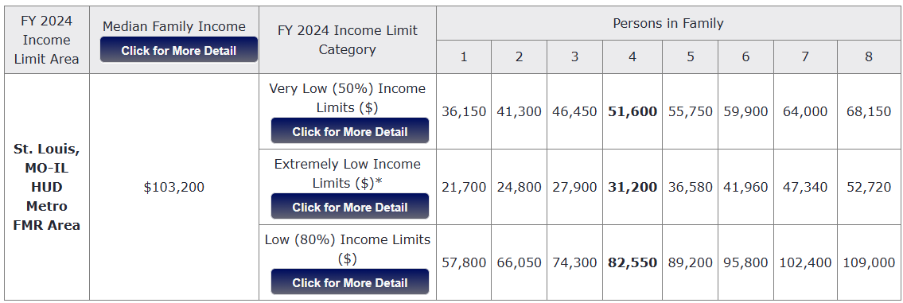
See https://www.huduser.gov/portal/datasets/il.html for most recent income limits.

Section 3 Worker Definition:
- A low or very low-income resident (the worker’s income for the previous or annualized calendar year is below the income limit established by HUD); or
- Employed by a Section 3 business concern; or
- A YouthBuild participant.
Targeted Section 3 Worker Definition:
- Employed by a Section 3 business concern or
- Currently meets or when hired met at least one of the following categories as documented within the past five years:
  - A resident of public housing; or
  - A resident of other public housing projects or Section 8-assisted housing; or
  - A YouthBuild participant.

Exhibit B

Exhibit C

Key Changes of Section 3 Final Rule Summary Chart

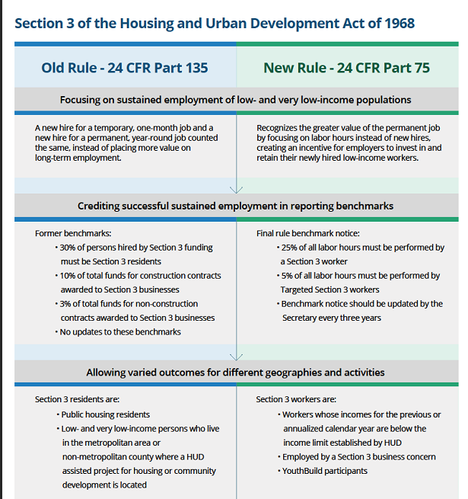
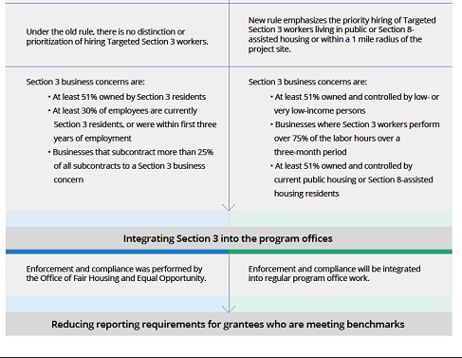

For additional resources visit:
https://www.hudexchange.info/programs/section-3/

https://www.hudexchange.info/programs/section-3/resources-and-tools/#section-3-tools

